Lab 4 - Screenshots

Nicholas Randles – B00058026



Question 1

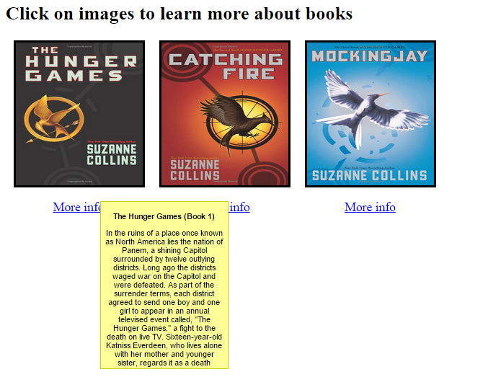

Question 2

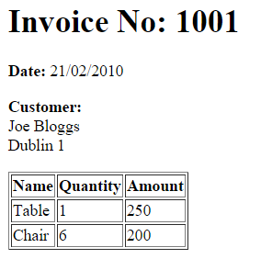

Question 3

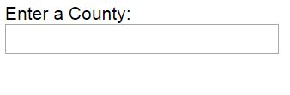

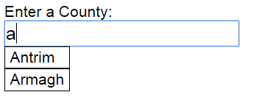

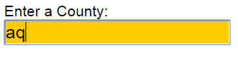

Question 4

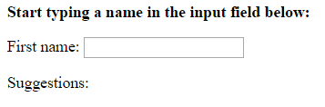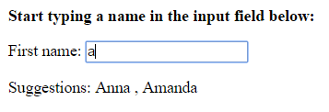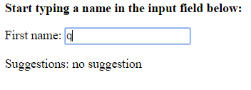

Question 5

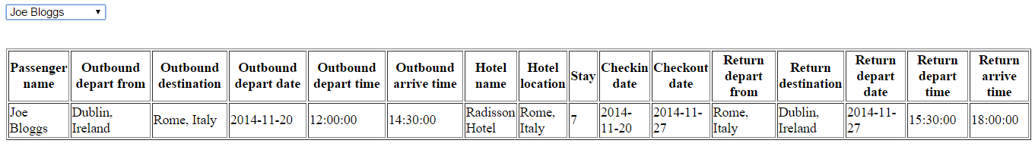

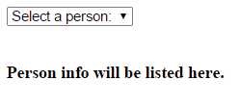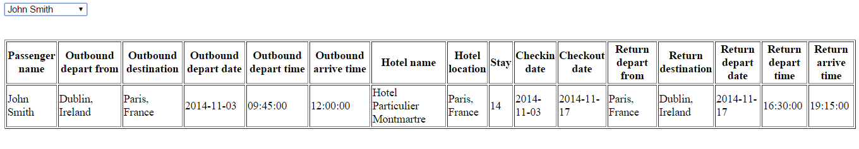

Database Entries

1. INSERT INTO `holidays`.`passengers` (`id`, `passengerName`, `outboundDepartFrom`, `outboundDestination`, `outboundDepartDate`, `outboundDepartTime`, `outboundArriveTime`, `hotelName`, `hotelLocation`, `stay`, `checkinDate`, `checkoutDate`, `returnDepartFrom`, `returnDestination`, `returnDepartDate`, `returnDepartTime`, `returnArriveTime`) VALUES (NULL, 'Joe Bloggs', 'Dublin, Ireland', 'Rome, Italy', '2014-11-20', '12:00:00', '14:30:00', 'Radisson Hotel', 'Rome, Italy', '7 ', '2014-11-20', '2014-11-27', 'Rome, Italy', 'Dublin, Ireland', '2014-11-27', '15:30:00', '18:00:00');
2. INSERT INTO `holidays`.`passengers` (`id`, `passengerName`, `outboundDepartFrom`, `outboundDestination`, `outboundDepartDate`, `outboundDepartTime`, `outboundArriveTime`, `hotelName`, `hotelLocation`, `stay`, `checkinDate`, `checkoutDate`, `returnDepartFrom`, `returnDestination`, `returnDepartDate`, `returnDepartTime`, `returnArriveTime`) VALUES (NULL, 'John Smith', 'Dublin, Ireland', 'Paris, France', '2014-11-03', '9:45:00', '12:00:00', 'Hotel Particulier Montmartre', 'Paris, France', '14', '2014-11-03', '2014-11-17', 'Paris, France', 'Dublin, Ireland', '2014-11-17', '16:30:00', '19:15:00');